Property Portal for Direct Landlord Listings
Student Name: Zeeshan Mahmood
Student ID: 20104546

Table of Contents
1. For Existing Work: Literature Review (Supporting Material Section) 3
Digital Disintermediation in the UK Private Rented Sector 3
Two-Sided Marketplace Design 3
Trust, Verification, and Algorithmic Risk-Profiling 4
Blockchain-Based Approaches to Rental Trust 5
Legal and Regulatory Considerations 5
Methodological Foundations and Synthesis 6
References 6
2. Lifecycle Stages and Tools Used 7
3. Professional, Ethical, Social, and Sustainability Issues 8
4. Critical Appraisal and Lessons Learned 10
Appendix: 11

1. For Existing Work: Literature Review (Supporting Material Section)

Digital Disintermediation in the UK Private Rented Sector
Over the last few years, the private rented sector (PRS) in the United Kingdom (UK) has emerged as a major new hub of digital disruption. Wainwright [1] looked at the impact of a fresh breed of rental proptech platforms (RPP) on the traditional power dynamic of landlords, letting agents and tenants. These platforms were found to be automated what was previously done manually by an agent, such as tenant screening, application processing and contract management; while also changing how ideal tenants are created through algorithmic 'scoring systems' constructed by platform entrepreneurs. This is the opportunity to eliminate the agent, which served as a middleman and is now quite expensive, whilst maintaining the same levels of trust, if not improving them. This truly is just the latest domino in a long line of the many breakthroughs suggested in real-estate services through AI, IoT, and blockchain technologies, as a recent systematic review by Al-haimi et al. [2] of thirty-six studies from around the world in the real estate industry confirms with the caveats of data-security, interoperability, and variable real estate digital-literacy among landlords and agencies. Combined, both studies reinforce the fact that the disintermediation movement is firmly in the hands of the rentals sector, both nationally in the UK as well as internationally, and neither of them actually proposes to provide an outline framework for a system that fully disintermediates the agent from end to end, which is what DirectLet can offer outright.

Two-Sided Marketplace Design
When building a platform capable of satisfying both sides of the housing market landlords and tenants, two-sided platform dynamics must be carefully addressed. As detailed by Wirtz et al. [3], peer2peer sharing-economy platforms can be divided into two types: product marketplaces, which simply change the ownership of a product, and capacity-constrained sharing platforms, where the shares are in the form of time limited and heterogeneous assets like a house or car. They argue that the capability of these platforms to generate the high degree of liquidity on which the concept is built depends more on their capacity to establish sufficient onboarding and reputation building systems than to own some underlying asset, and that it is essential for them to manage indirect network effects between their user groups. This has direct implications for the architecture of DirectLet: first, the efficient matching between landlords and tenants is fundamental for the viability of a platform; and second, elements to build trust like verified profiles and transparent conversation threads are no mere add-on, but necessary conditions for the trust that arises between its users and makes its platform usable and viable. Using these ideas, this research aims to shed light on the viability and manipulation of current and future landlord-tenant relations, such as renters discussing and viewing attributes and images of their living space on the app, and landlords providing and editing its exclusive details about rental experiences. As a result, we intend to expose the viability and manipulation of existing and prospective relationships aimed at landlord and tenant in DirectLet with the aim of shedding light on the relation between their attributes and what is to be seen on the app, and the relation between their images and what is to be seen on the app or not, as well as the relation between landlords' supplying of and renters' demands for exclusive details about their residential experiences on the platform

Trust, Verification, and Algorithmic Risk-Profiling
The issue of trust and information asymmetry is a recurring and on-going topic in the broader PRS literature. Wallace et al. [4] polled landlords and analyzed the use of software to assist landlords in doing digital tenant risk assessment in England, revealing that when it came to judging the suitability of an applicant, landlords were more often utilizing "ordinal tenants" applicants who were increasingly being assessed by quantitative and data-driven proxies rather than by the landlord's subjective judgment. This is good for consistency of procedures, but it leaves the possibility for tenants to be excluded on the basis of financial irregularities that do not fit the standards set in specific scoring systems, something that is critical to build into every tool implementation at the design phase, which applies to DirectLet's verification and screening procedures. Similarly, Ciocanel et al. [5] explored the trends of Open Banking in tenant referencing in the UK, finding that landlords and referencing providers have adapted to increasingly ask potential tenants to provide real-time bank-transaction data as a more "reassuring" alternative to the older and cumbersome utilization of paper-based proof of income. The study emphasizes, while simplifying the application process, questions of consent, data minimization and proportionality are left unanswered, concerns which are right on target with DirectLet's identity and affordable verification procedures, and its general responsibility to only ask for data that is truly essential to a particular transaction.

Blockchain-Based Approaches to Rental Trust
Also recently there has been a strand of literature examining how blockchain technology might be a structural and technical answer to deep-seated rental-sector issues of trust. To meet GDPR-like privacy requirements for personal data, Tseng et al. [6] suggest a hybrid ledger architecture, whereby a permissioned Hyperledger Fabric ledger for rental business transactions and a separate Decentralized Identity chain for identity verification processes can coexist while utilizing public information and private information in the ledger as a way to provide visibility for/opacity of the market. To make the rental program GDPR compliant, Proença et al. similarly developed a GDPR-compliant blockchain rental platform for a commercial landlord [7] to ensure that sensitive tenants' and landlords' data is not stored directly on-chain. Taking this one step further, into the post-contract phase of the rental arrangements, Jaodun and Bouafia [8] modelled a blockchain-based rental agreement and a dispute-resolution process, where they applied game theory to show that low-cost dispute resolution and the automation of security deposit payments significantly reduce the structural incentives for landlords to take advantage of renters if they choose a non-blockchain-based plan, which matches DirectLet's own choice of conventional, non-blockchain-based architecture. Together, this collection of work shows that automation and cryptographic verification can significantly shift the balance of power between landlords and tenants, although most of these systems have been only simulated with laboratory users and not deployed to real users in actual systems.

Legal and Regulatory Considerations
The basis for everything listed above is the General Data Protection Regulation [9] which dictates how any rental platform that records data about a UK or EU applicant or renter can lawfully do so, such as gathering financial details, identity-verification information, and more. The principles of directness in data minimisation, purpose limitation and lawful basis are directly applicable, meaning that the features of DirectLet's verification and messaging service, and its payment-processing capabilities, must be geared toward the specific and minimal purpose that they are designed to serve.

Methodological Foundations and Synthesis
In the methodological discussion, Hevner et al [10] outline the key paradigm of method in design-science research that forms the foundation for this work: "information-systems research must yield and examine a useful artefact that solves a meaningful problem that has arisen in an organisation rather than describing or explaining an artefact from a distance. Taken together, the literature reviewed here confirms three things: digital disintermediation in UK private rented sectors is not yet complete and emerging; trust, verification, and data handling proportionate are the key problems that remain unsolved in the design of direct-letting platforms; the resulting literature contains numerous prototypes treating blockchain as a tool for private rental, but these have yet to be used in an end-to-end consumer platform that integrates listing, communication, scheduling, payment, and verification into a unified system. DirectLet has been designed within this identified gap using two-sided platform design principles, and the cautions regarding risk about which the entire proptech and tenant-referencing literature speaks, with a keen focus on a traditional and non-blockchain-based architecture to ensure the highest possible degree of usability and developability in relation to the measured scope and time of this MSc research project.

References
[1] T. Wainwright, "Rental proptech platforms: Changing landlord and tenant power relations in the UK private rental sector?" Environment and Planning A: Economy and Space, vol. 55, no. 2, pp. 339–358, 2023.
[2] B. Al-haimi, H. Khalid, N. H. Zakaria, and T. H. Jasimin, "Digital transformation in the real estate industry: A systematic literature review of current technologies, benefits, and challenges," International Journal of Information Management Data Insights, vol. 5, no. 1, art. 100340, 2025.
[3] J. Wirtz, K. K. F. So, M. A. Mody, S. Q. Liu, and H. H. Chun, "Platforms in the peer-to-peer sharing economy," Journal of Service Management, vol. 30, no. 4, pp. 452–483, 2019.
[4] A. Wallace, D. Beer, R. Burrows, A. Ciocănel, and J. Cussens, "Algorithmic tenancies and the ordinal tenant: digital risk-profiling in England's private rented sector," Housing Studies, vol. 41, no. 2, pp. 331–351, 2025.
[5] A. Ciocănel, A. Wallace, D. Beer, J. Cussens, and R. Burrows, "Open Banking and data reassurance: the case of tenant referencing in the UK," Information, Communication & Society, vol. 27, no. 9, pp. 1810–1825, 2024.
[6] C.-H. Tseng, Y.-H. Hsieh, Y.-Y. Chang, and S.-M. Yuan, "Towards a trustworthy rental market: A blockchain-based housing system architecture," Electronics, vol. 14, no. 15, art. 3121, 2025.
[7] A. S. Proença, T. R. Dias, and M. P. Correia, "Blockchain based residential smart rent," arXiv preprint arXiv:2402.05737, 2024.
[8] M. Jaodun and K. Bouafia, "Analysis and evaluation of a blockchain-based framework for decentralized rental agreements and dispute resolution," Blockchains, vol. 3, no. 2, art. 8, 2025.
[9] European Parliament and Council of the European Union, "Regulation (EU) 2016/679 (General Data Protection Regulation)," Official Journal of the European Union, vol. L119, pp. 1–88, 2016.
[10] A. R. Hevner, S. T. March, J. Park, and S. Ram, "Design science in information systems research," MIS Quarterly, vol. 28, no. 1, pp. 75–105, 2004.

2. Lifecycle Stages and Tools Used
The overall research methodology to develop DirectLet was Design Science Research (DSR) and the software development approach was Agile Scrum. The development was split up into six iterative sprints with each targeted at a different sub-system of the platform, allowing for continual testing and development prior to moving onto the next sprint.
In Sprint 1, user authentication and role-based access control were the key topics. To enable three distinct roles for the user: landlord, tenant and administrator, JWT based authentication was implemented. MongoDB schemas were designed in this phase and the data architecture for all the subsequent modules were based on this design. In Sprint 2, properties were listed using the Cloudinary image upload, advanced search and filtering options were added, and map integration with Google Maps API was implemented, so that tenants will be able to search properties geographically. The new features added in Sprint 3 include real-time messaging between landlords and tenants, and a viewing appointment scheduling system where tenants can make an appointment with a property and confirm it with the landlord in real-time. Sprint 4 added Stripe Connect as a feature to mimic a rent collection and payment of deposits, making it possible to simulate real transaction processes without sending or receiving financial information. Sprint 5 featured the new visualization of landlord analytics with Chart.js, which includes such performance metrics as views of listings, enquiry rates and viewings scheduled. Sprint 6 introduced verification methods (email, identity verification, etc.), and did extensive functional, integration, usability and performance testing.
The tools used throughout the development process included: React for the front-end, component-based user interface; Node.js and GraphQL for implementing the back-end API and logic; MongoDB with Mongoose for managing the data; Git and GitHub for version control and sprint-based branch management; Postman for testing API endpoints; Jest for unit testing; and VS Code as the primary development environment with the addition of the Faker.js library which was used to create synthetic datasets of properties for testing purposes; and Figma was used to create initial UI wire frames and prototyping. Project Management was monitored by Trello with each sprint represented by a column of the board, indicating what was planned, in progress or completed.

3. Professional, Ethical, Social, and Sustainability Issues
Professional: DirectLet is developed in compliance with the BCS Code of Conduct and the ACM Code of Ethics which includes the tenets of practitioners to behave with integrity, place public interest first and to design systems which are safe and reliable and respectful of users' rights. These principles were applied during development from the beginning, such as in data handling and access management, but also in the level of transparency of the platform functions.
Ethical: The site gathers personal information such as contact information, identity documents, financial facts and property information. All data handling was planned to adhere to the UK General Data Protection Regulation (UK GDPR) and the Data Protection Act 2018, which uses the principles of data minimization, purpose limitation and lawful basis of processing. User's passwords are hashed with bcrypt, communications are encrypted and role-based access controls mean that users can only access data that is relevant to their role. Ethical approval was requested from the University and informed consent was obtained from all participants before they participated in any usability testing with human participants.
The verification module of the platform brings more ethical issues. As literature shows, algorithmic tenant screening poses a risk of excluding applicants because of financial measures that do not adequately capture their suitability. Therefore, DirectLet's verification method was designed to be as simple and clear as possible and only ask for information which is relevant to confirming a tenancy, without using a hidden scoring system which may discriminate.
Social: DirectLet fills a specific social need by minimizing the financial transaction costs of small landlords and tenants in dealing with the private rental market. The platform also cuts out the middleman's cut of £500-£1500 per tenancy to make it more affordable and accessible for both parties. On top of that, the platform has fraud prevention features like verified profiles and reporting features, which provide additional security for vulnerable users in an otherwise poorly regulated sector.
Sustainability: The rental process can be digitized, which means that less paper is used, office visits are avoided, and the use of correspondence by agents can be reduced, thus reducing the consumption of resources during the rental process. The platform runs on cloud infrastructure, which is more efficient to use than on premise server infrastructures because of its increased energy efficiency per transaction. Socially, the platform helps to sustain the private rental sector over the longer-term by improving landlord-tenant relations, helping to ensure they are more equitable and transparent, which helps to minimize conflict and tenancy breakdowns.

4. Critical Appraisal and Lessons Learned
DirectLet was able to provide an integrated and functional direct landlord platform for the entire rental lifecycle. To keep development time as fast as possible and the prototypes feasible within the scope of the MSc project, the key design choices were made: using GraphQL instead of REST, MongoDB instead of a relational database and the payment simulation instead of live Stripe payments. GraphQL was found to be specifically useful when it comes to minimizing over-fetching data for properties, users and bookings in complex nested queries.
The most important thing that posed a challenge was integrating real-time messaging (socket.io) with GraphQL subscriptions, which was a lot of debugging for connection lifecycle management. Looking back, it would have been better to make the messaging service a microservice from the get-go.
Usability testing has shown that the interface for scheduling was initially confusing to some tenants and the UI was changed to enhance the ability to complete the tasks. This was to remind them that user involvement is important in the early stages; the term 'not as a late stage activity'.
In general, the project proved the feasibility of a fully integrated, agent-less rental system in the context of an academic project. For future works, greater emphasis should be placed upon the live integration of payment solutions, the development of mobile applications, and beyond the prototype stage, a longitudinal research of consumer trust and uptake should be conducted.

Appendix:
Register Page:
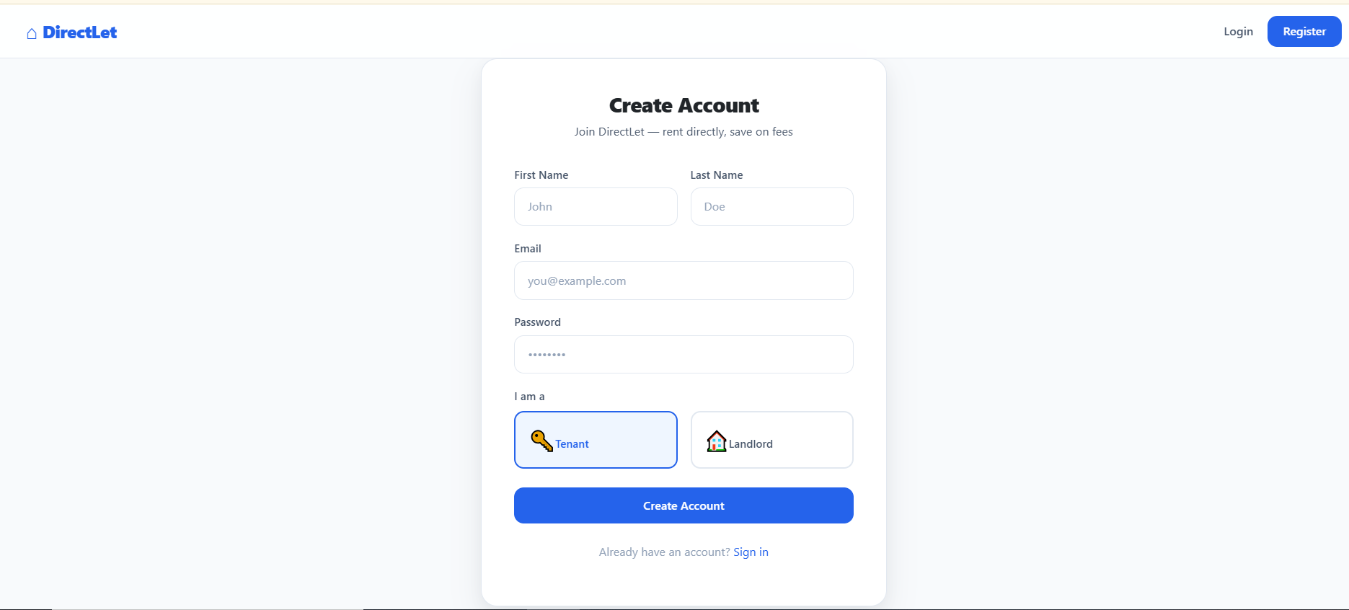

Login Page:
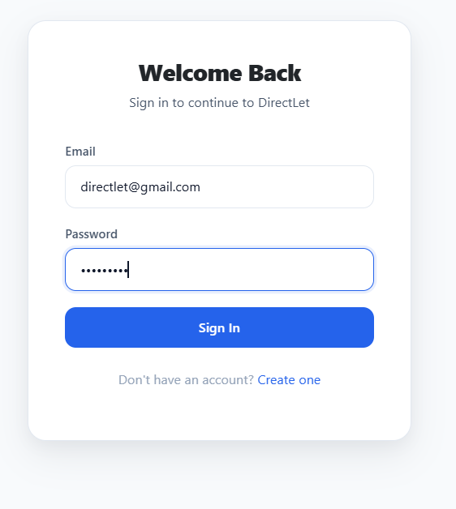
Landlord Dashboard
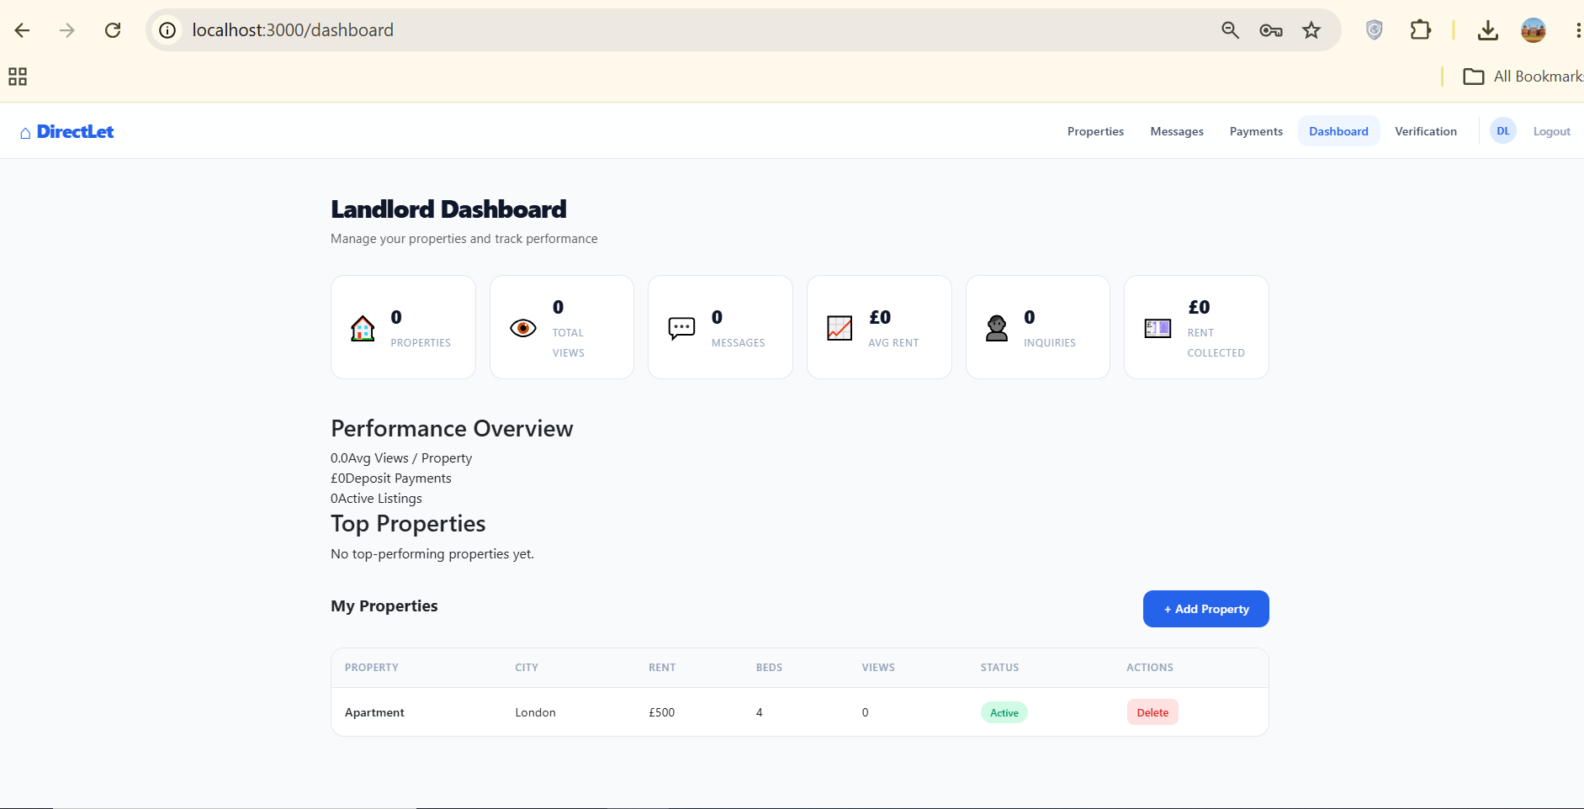

Messages Page:
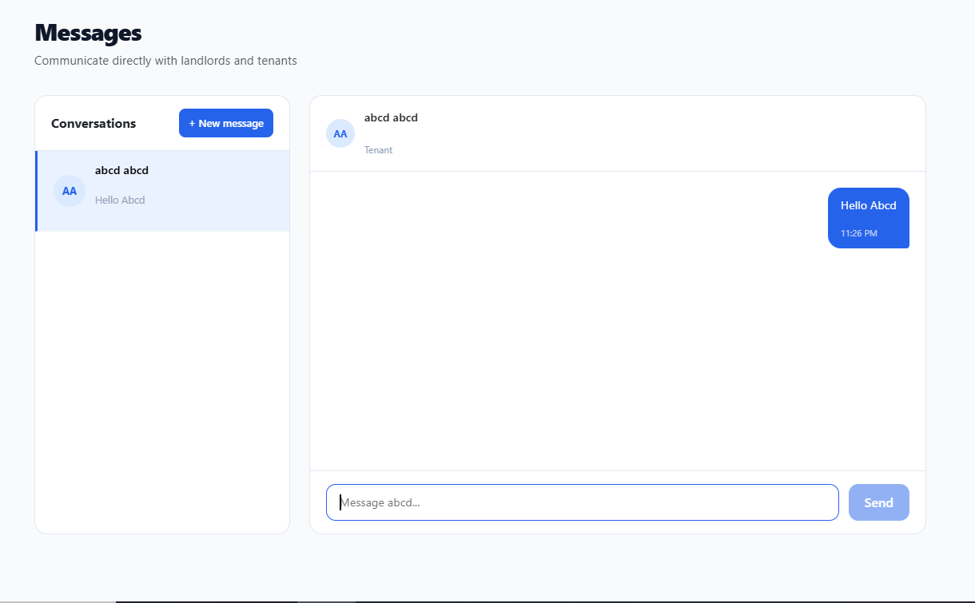

Properties Listing Page:
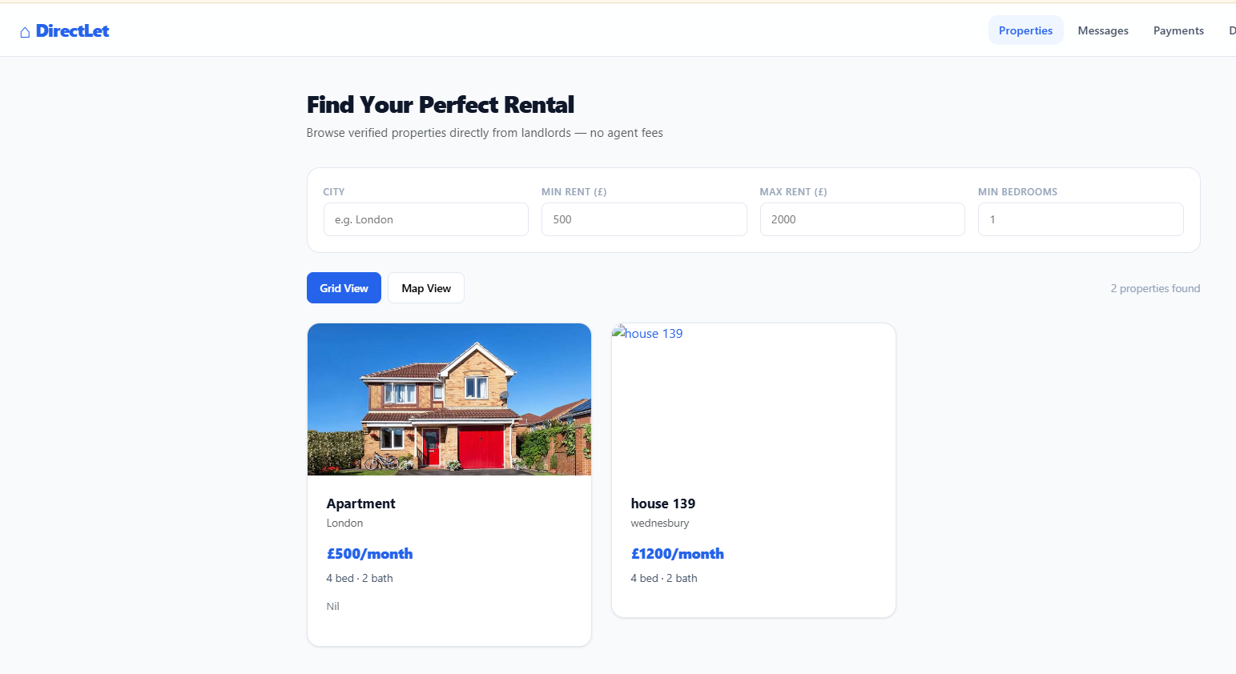

Verification Page:
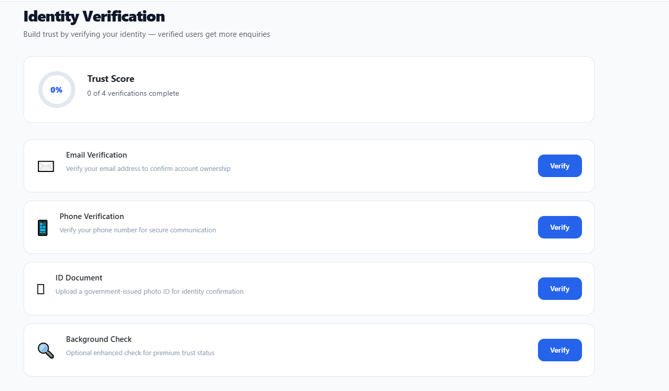

Server.js File
// Entry point for DirectLet Backend
// Phase 1: Authentication & User Management

require('dotenv').config();
const express = require('express');
const http = require('http');
const cors = require('cors');
const { ApolloServer } = require('apollo-server-express');
const connectDB = require('./config/db');
const { typeDefs, resolvers } = require('./graphql');
const authMiddleware = require('./middleware/auth');
const { initSocket } = require('./socket');

const app = express();
const PORT = process.env.PORT || 4000;

// Middleware
const allowedOrigins = [
'http://localhost:3000',
'http://127.0.0.1:3000',
'http://192.168.18.33:3000',
'http://192.168.10.49:3000',
'http://localhost:5000',
];

app.use(cors({
origin: (origin, callback) => {
if (!origin || allowedOrigins.includes(origin)) {
callback(null, true);
} else {
callback(new Error(`CORS origin not allowed: ${origin}`));
}
},
credentials: true,
methods: ['GET', 'POST', 'OPTIONS'],
allowedHeaders: ['Content-Type', 'Authorization'],
}));
app.use(express.json());
app.use(authMiddleware);

// Serve uploaded files
const path = require('path');
const uploadsPath = path.join(__dirname, '..', 'uploads');
app.use('/uploads', express.static(uploadsPath));

// Uploads route
const uploadsRouter = require('./routes/uploads');
app.use('/api/uploads', uploadsRouter);

// Apollo Server Setup
async function startServer() {
await connectDB();

const server = new ApolloServer({
typeDefs,
resolvers,
context: ({ req }) => ({ user: req.user }),
});

await server.start();
server.applyMiddleware({ app, cors: false }); // CORS already handled by Express

const httpServer = http.createServer(app);
initSocket(httpServer);

httpServer.listen(PORT, () => {
console.log(`DirectLet Backend running at http://localhost:${PORT}/graphql`);
});
}

startServer().catch(err => {
console.error('Server startup failed:', err);
process.exit(1);
});

Socket.js file
const { Server } = require('socket.io');

let io;

function initSocket(server) {
io = new Server(server, {
cors: {
origin: [
'http://localhost:3000',
'http://127.0.0.1:3000',
],
methods: ['GET', 'POST'],
credentials: true,
},
});

io.on('connection', (socket) => {
console.log('Socket connected:', socket.id);

socket.on('join', ({ userId }) => {
if (userId) {
socket.join(`user_${userId}`);
}
});

socket.on('disconnect', () => {
console.log('Socket disconnected:', socket.id);
});
});

return io;
}

function getSocket() {
if (!io) throw new Error('Socket.io not initialized');
return io;
}

module.exports = { initSocket, getSocket };

typeDefs.js File
// GraphQL Type Definitions
// Complete schema for DirectLet Platform

const { gql } = require('apollo-server-express');

const typeDefs = gql`
type User {
id: ID!
email: String!
firstName: String!
lastName: String!
role: String!
phone: String
avatar: String
isVerified: Boolean!
createdAt: String
}

type Property {
id: ID!
title: String!
description: String
landlord: User
landlordId: ID!
address: String
city: String
postcode: String
latitude: Float
longitude: Float
bedrooms: Int
bathrooms: Int
rent: Int
deposit: Int
images: [String]
amenities: [String]
availableFrom: String
isActive: Boolean
viewCount: Int
createdAt: String
}

type Message {
id: ID!
senderId: ID!
receiverId: ID!
sender: User
receiver: User
propertyId: ID
content: String!
isRead: Boolean!
createdAt: String!
}

type Conversation {
user: User!
lastMessage: Message
unreadCount: Int!
}

type Viewing {
id: ID!
property: Property
tenant: User
landlord: User
propertyId: ID!
tenantId: ID!
landlordId: ID!
scheduledDate: String!
duration: Int
status: String!
notes: String
createdAt: String
}

type Payment {
id: ID!
tenantId: ID!
propertyId: ID!
property: Property
amount: Int!
type: String!
status: String!
stripePaymentId: String
stripeClientSecret: String
createdAt: String
}

type Verification {
id: ID!
userId: ID!
type: String!
status: String!
documentUrl: String
verificationDate: String
expiryDate: String
createdAt: String
}

type AuthPayload {
token: String!
user: User!
}

type DashboardStats {
totalProperties: Int!
totalViews: Int!
totalMessages: Int!
activeListings: Int!
totalViewings: Int!
totalPayments: Float!
averageRent: Float!
averageViews: Float!
totalInquiries: Int!
totalRentPayments: Float!
totalDepositPayments: Float!
}

type PropertyPerformance {
property: Property!
views: Int!
inquiries: Int!
scheduledViewings: Int!
}

type PaymentIntent {
clientSecret: String!
paymentId: ID!
}

type Query {
me: User
properties(skip: Int, limit: Int, city: String, minRent: Int, maxRent: Int, bedrooms: Int): [Property]
property(id: ID!): Property
myProperties: [Property]
searchProperties(query: String!, minRent: Int, maxRent: Int, bedrooms: Int): [Property]
messages(userId: ID!): [Message]
conversations: [Conversation]
messageContacts: [User!]!
myViewings: [Viewing]
propertyViewings(propertyId: ID!): [Viewing]
myPayments: [Payment]
propertyPayments(propertyId: ID!): [Payment]
dashboardStats: DashboardStats
topProperties(limit: Int): [PropertyPerformance]
propertyPerformance(propertyId: ID!): PropertyPerformance
myVerifications: [Verification]
allUsers(role: String): [User]
allVerifications(status: String): [Verification]
}

type Mutation {
register(email: String!, password: String!, firstName: String!, lastName: String!, role: String!): AuthPayload
login(email: String!, password: String!): AuthPayload
updateProfile(firstName: String, lastName: String, phone: String, avatar: String): User
createProperty(title: String!, description: String, address: String, city: String, postcode: String, latitude: Float, longitude: Float, bedrooms: Int, bathrooms: Int, rent: Int!, deposit: Int, images: [String], amenities: [String], availableFrom: String): Property
updateProperty(id: ID!, title: String, description: String, address: String, city: String, rent: Int, deposit: Int, bedrooms: Int, bathrooms: Int, images: [String], amenities: [String], isActive: Boolean): Property
deleteProperty(id: ID!): Boolean
sendMessage(receiverId: ID!, content: String!, propertyId: ID): Message
markMessageRead(id: ID!): Message
scheduleViewing(propertyId: ID!, scheduledDate: String!, notes: String): Viewing
updateViewingStatus(id: ID!, status: String!): Viewing
createPaymentIntent(amount: Int!, propertyId: ID!, type: String!): PaymentIntent
confirmPayment(paymentId: ID!): Payment
submitVerification(type: String!, documentUrl: String): Verification
updateVerificationStatus(id: ID!, status: String!): Verification
}
`;

module.exports = typeDefs;

resolver.js File
// GraphQL Resolvers
// Complete resolvers for all DirectLet features

const userRepository = require('../repositories/userRepository');
const propertyRepository = require('../repositories/propertyRepository');
const messageRepository = require('../repositories/messageRepository');
const viewingRepository = require('../repositories/viewingRepository');
const paymentRepository = require('../repositories/paymentRepository');
const verificationRepository = require('../repositories/verificationRepository');
const messagingService = require('../services/messagingService');
const { generateToken } = require('../utils/jwt');
const stripe = require('../config/stripe');

const resolvers = {
Query: {
// Auth
me: async (_, __, { user }) => {
if (!user) throw new Error('Unauthorized');
return await userRepository.findById(user.id);
},

// Properties
properties: async (_, { skip = 0, limit = 20, city, minRent, maxRent, bedrooms }) => {
const filter = { isActive: true };
if (city) filter.city = { $regex: city, $options: 'i' };
if (minRent || maxRent) {
filter.rent = {};
if (minRent) filter.rent.$gte = minRent;
if (maxRent) filter.rent.$lte = maxRent;
}
if (bedrooms) filter.bedrooms = { $gte: bedrooms };
return await propertyRepository.findAllWithFilter(filter, skip, limit);
},

property: async (_, { id }) => {
const property = await propertyRepository.findById(id);
if (property) {
property.viewCount = (property.viewCount || 0) + 1;
await property.save();
}
return property;
},

myProperties: async (_, __, { user }) => {
if (!user) throw new Error('Unauthorized');
return await propertyRepository.findByLandlordId(user.id);
},

searchProperties: async (_, { query, minRent, maxRent, bedrooms }) => {
const filter = {
isActive: true,
$or: [
{ title: { $regex: query, $options: 'i' } },
{ city: { $regex: query, $options: 'i' } },
{ address: { $regex: query, $options: 'i' } },
{ description: { $regex: query, $options: 'i' } },
],
};
if (minRent || maxRent) {
filter.rent = {};
if (minRent) filter.rent.$gte = minRent;
if (maxRent) filter.rent.$lte = maxRent;
}
if (bedrooms) filter.bedrooms = { $gte: bedrooms };
return await propertyRepository.search(filter);
},

// Messages
messages: async (_, { userId }, { user }) => {
if (!user) throw new Error('Unauthorized');
return await messageRepository.findConversation(user.id, userId);
},

conversations: async (_, __, { user }) => {
if (!user) throw new Error('Unauthorized');
const messages = await messageRepository.findByUser(user.id);

const conversationMap = new Map();
for (const msg of messages) {
const otherId = msg.senderId.toString() === user.id ? msg.receiverId.toString() : msg.senderId.toString();
if (!conversationMap.has(otherId)) {
const unreadCount = await messageRepository.countUnreadForConversation(otherId, user.id);
conversationMap.set(otherId, { userId: otherId, lastMessage: msg, unreadCount });
}
}

const conversations = [];
for (const [userId, data] of conversationMap) {
const otherUser = await userRepository.findById(userId);
if (otherUser) {
conversations.push({ user: otherUser, lastMessage: data.lastMessage, unreadCount: data.unreadCount });
}
}
return conversations;
},

messageContacts: async (_, __, { user }) => {
if (!user) throw new Error('Unauthorized');

/*
Production rule:
- Tenant should see landlords attached to available properties.
- Landlord should see tenants who submitted enquiries or bookings.
- Never expose all users without an authorization rule.
*/

const allowedRole =
user.role === 'LANDLORD' || user.role === 'landlord'
? 'TENANT'
: 'LANDLORD';

return await userRepository.findContactCandidates(user.id, allowedRole);
},

// Viewings
myViewings: async (_, __, { user }) => {
if (!user) throw new Error('Unauthorized');
const filter = user.role === 'landlord' ? { landlordId: user.id } : { tenantId: user.id };
return await viewingRepository.findMany(filter, { scheduledDate: -1 });
},

propertyViewings: async (_, { propertyId }, { user }) => {
if (!user) throw new Error('Unauthorized');
return await viewingRepository.findMany({ propertyId }, { scheduledDate: -1 });
},

// Payments
myPayments: async (_, __, { user }) => {
if (!user) throw new Error('Unauthorized');
return await paymentRepository.findByTenantId(user.id);
},

propertyPayments: async (_, { propertyId }, { user }) => {
if (!user) throw new Error('Unauthorized');
return await paymentRepository.findByPropertyId(propertyId);
},

// Analytics
dashboardStats: async (_, __, { user }) => {
if (!user || user.role !== 'landlord') throw new Error('Unauthorized');
const properties = await propertyRepository.findByLandlordId(user.id);
const propertyIds = properties.map(p => p._id);
const totalViews = properties.reduce((sum, p) => sum + (p.viewCount || 0), 0);
const totalMessages = await messageRepository.countByUser(user.id);
const totalViewings = await viewingRepository.count({ landlordId: user.id });
const payments = await paymentRepository.findCompletedByPropertyIds(propertyIds);
const totalPayments = payments.reduce((sum, p) => sum + p.amount, 0);
const totalInquiries = await messageRepository.countByPropertyIds(propertyIds);
const totalRentPayments = payments.filter(p => p.type === 'rent').reduce((sum, p) => sum + p.amount, 0);
const totalDepositPayments = payments.filter(p => p.type === 'deposit').reduce((sum, p) => sum + p.amount, 0);
const averageRent = properties.length ? properties.reduce((sum, p) => sum + (p.rent || 0), 0) / properties.length : 0;
const averageViews = properties.length ? totalViews / properties.length : 0;

return {
totalProperties: properties.length,
totalViews,
totalMessages,
activeListings: properties.filter(p => p.isActive).length,
totalViewings,
totalPayments,
averageRent,
averageViews,
totalInquiries,
totalRentPayments,
totalDepositPayments,
};
},

topProperties: async (_, { limit = 5 }, { user }) => {
if (!user || user.role !== 'landlord') throw new Error('Unauthorized');
const properties = await propertyRepository.findByLandlordIdSorted(user.id, limit);
return await Promise.all(properties.map(async (property) => {
const inquiries = await messageRepository.countByPropertyId(property._id);
const scheduledViewings = await viewingRepository.count({ propertyId: property._id });
return {
property,
views: property.viewCount || 0,
inquiries,
scheduledViewings,
};
}));
},

propertyPerformance: async (_, { propertyId }, { user }) => {
if (!user) throw new Error('Unauthorized');
const property = await propertyRepository.findById(propertyId);
if (!property) throw new Error('Property not found');
const inquiries = await messageRepository.countByPropertyId(propertyId);
const scheduledViewings = await viewingRepository.count({ propertyId });
return { property, views: property.viewCount || 0, inquiries, scheduledViewings };
},

// Verification
myVerifications: async (_, __, { user }) => {
if (!user) throw new Error('Unauthorized');
return await verificationRepository.findByUserId(user.id);
},

// Admin
allUsers: async (_, { role }, { user }) => {
if (!user || user.role !== 'admin') throw new Error('Unauthorized');
const filter = role ? { role } : {};
return await userRepository.findByRoleFilter(filter, role);
},

allVerifications: async (_, { status }, { user }) => {
if (!user || user.role !== 'admin') throw new Error('Unauthorized');
const filter = status ? { status } : {};
return await verificationRepository.findMany(filter);
},
},

Mutation: {
// Auth
register: async (_, { email, password, firstName, lastName, role }) => {
const existing = await userRepository.findByEmail(email);
if (existing) throw new Error('Email already registered');
const user = await userRepository.create({ email, password, firstName, lastName, role });
const token = generateToken(user._id);
return { token, user };
},

login: async (_, { email, password }) => {
const user = await userRepository.findByEmail(email);
if (!user || !(await user.comparePassword(password))) {
throw new Error('Invalid credentials');
}
const token = generateToken(user._id);
return { token, user };
},

updateProfile: async (_, args, { user }) => {
if (!user) throw new Error('Unauthorized');
return await userRepository.update(user.id, args);
},

// Properties
createProperty: async (_, args, { user }) => {
if (!user || user.role !== 'landlord') throw new Error('Only landlords can create properties');
return await propertyRepository.create({ ...args, landlordId: user.id });
},

updateProperty: async (_, { id, ...updates }, { user }) => {
if (!user) throw new Error('Unauthorized');
const property = await propertyRepository.findById(id);
if (!property) throw new Error('Property not found');
if (property.landlordId.toString() !== user.id && user.role !== 'admin') {
throw new Error('Not authorized to update this property');
}
return await propertyRepository.update(id, updates);
},

deleteProperty: async (_, { id }, { user }) => {
if (!user) throw new Error('Unauthorized');
const property = await propertyRepository.findById(id);
if (!property) throw new Error('Property not found');
if (property.landlordId.toString() !== user.id && user.role !== 'admin') {
throw new Error('Not authorized to delete this property');
}
await propertyRepository.delete(id);
return true;
},

// Messages
sendMessage: async (_, { receiverId, content, propertyId }, { user, io }) => {
if (!user) {
throw new Error('Authentication required');
}

const cleanContent = content.trim();

if (!cleanContent) {
throw new Error('Message cannot be empty');
}

if (String(user.id) === String(receiverId)) {
throw new Error('You cannot message yourself');
}

const receiver = await userRepository.findById(receiverId);

if (!receiver) {
throw new Error('Recipient not found');
}

const message = await messagingService.sendMessage(user.id, receiverId, cleanContent, propertyId);

/*
Emit to the receiver's socket room using context.io
Use the same room name your socket join handler uses.
*/
if (io) {
io.to(String(receiverId)).emit('newMessage', message);
}

return message;
},

markMessageRead: async (_, { id }, { user }) => {
if (!user) throw new Error('Unauthorized');
return await messageRepository.markAsRead(id);
},

// Viewings
scheduleViewing: async (_, { propertyId, scheduledDate, notes }, { user }) => {
if (!user) throw new Error('Unauthorized');
const property = await propertyRepository.findById(propertyId);
if (!property) throw new Error('Property not found');
return await viewingRepository.create({
propertyId,
tenantId: user.id,
landlordId: property.landlordId,
scheduledDate: new Date(scheduledDate),
notes,
});
},

updateViewingStatus: async (_, { id, status }, { user }) => {
if (!user) throw new Error('Unauthorized');
const viewing = await viewingRepository.findById(id);
if (!viewing) throw new Error('Viewing not found');
if (viewing.landlordId.toString() !== user.id && user.role !== 'admin') {
throw new Error('Not authorized');
}
return await viewingRepository.update(id, { status });
},

// Payments
createPaymentIntent: async (_, { amount, propertyId, type }, { user }) => {
if (!user) throw new Error('Unauthorized');
try {
const intent = await stripe.paymentIntents.create({
amount: amount * 100,
currency: 'gbp',
metadata: { tenantId: user.id, propertyId, type },
});
const payment = await paymentRepository.create({
tenantId: user.id,
propertyId,
amount,
type,
stripePaymentId: intent.id,
status: 'pending',
});
return { clientSecret: intent.client_secret, paymentId: payment._id };
} catch (error) {
throw new Error(`Payment failed: ${error.message}`);
}
},

confirmPayment: async (_, { paymentId }, { user }) => {
if (!user) throw new Error('Unauthorized');
return await paymentRepository.update(paymentId, { status: 'completed' });
},

// Verification
submitVerification: async (_, { type, documentUrl }, { user }) => {
if (!user) throw new Error('Unauthorized');
return await verificationRepository.create({ userId: user.id, type, documentUrl, status: 'pending' });
},

updateVerificationStatus: async (_, { id, status }, { user }) => {
if (!user || user.role !== 'admin') throw new Error('Unauthorized');
const verification = await verificationRepository.update(id, { status, verificationDate: status === 'verified' ? new Date() : null });
if (status === 'verified') {
await userRepository.update(verification.userId, { isVerified: true });
}
return verification;
},
},

// Field resolvers
Property: {
landlord: async (property) => await userRepository.findById(property.landlordId),
},
Message: {
sender: async (message) => await userRepository.findById(message.senderId),
receiver: async (message) => await userRepository.findById(message.receiverId),
},
Viewing: {
property: async (viewing) => await propertyRepository.findById(viewing.propertyId),
tenant: async (viewing) => await userRepository.findById(viewing.tenantId),
landlord: async (viewing) => await userRepository.findById(viewing.landlordId),
},
Payment: {
property: async (payment) => await propertyRepository.findById(payment.propertyId),
},
};

module.exports = resolvers;

